**Title : EECS 1022 Lab 04 - TABULATOR**

**Passport York username : kumarraj**

**Full Name : Rajkumar Balakrishnan Lakshmi (213141197)**

**Partner's Passport York - vhema**

**Partner's Name - Hemambika Vaidyanathan**

**Introduction:**

In this lab our objective was to create an app that calculates the Tax for a range of annual income when a button is clicked. Android studio made it easier for us to build the app. The app consisted of  three text boxes  respectively for the user to input the the range of annual income and the increment value of it. It also consisted of a button, which on click calculated the Tax, Average Interest, Marginal Interest, CPP & Ei values from the users input and displayed it in a table format in rows and columns respectively. the output also had a scroll view which made it easier for the user to read through the output.

**Results:**

**Task 2:**We first tested the model using public static void main, and the output was perfectly correct as expected. Here is a screenshot showing the result:

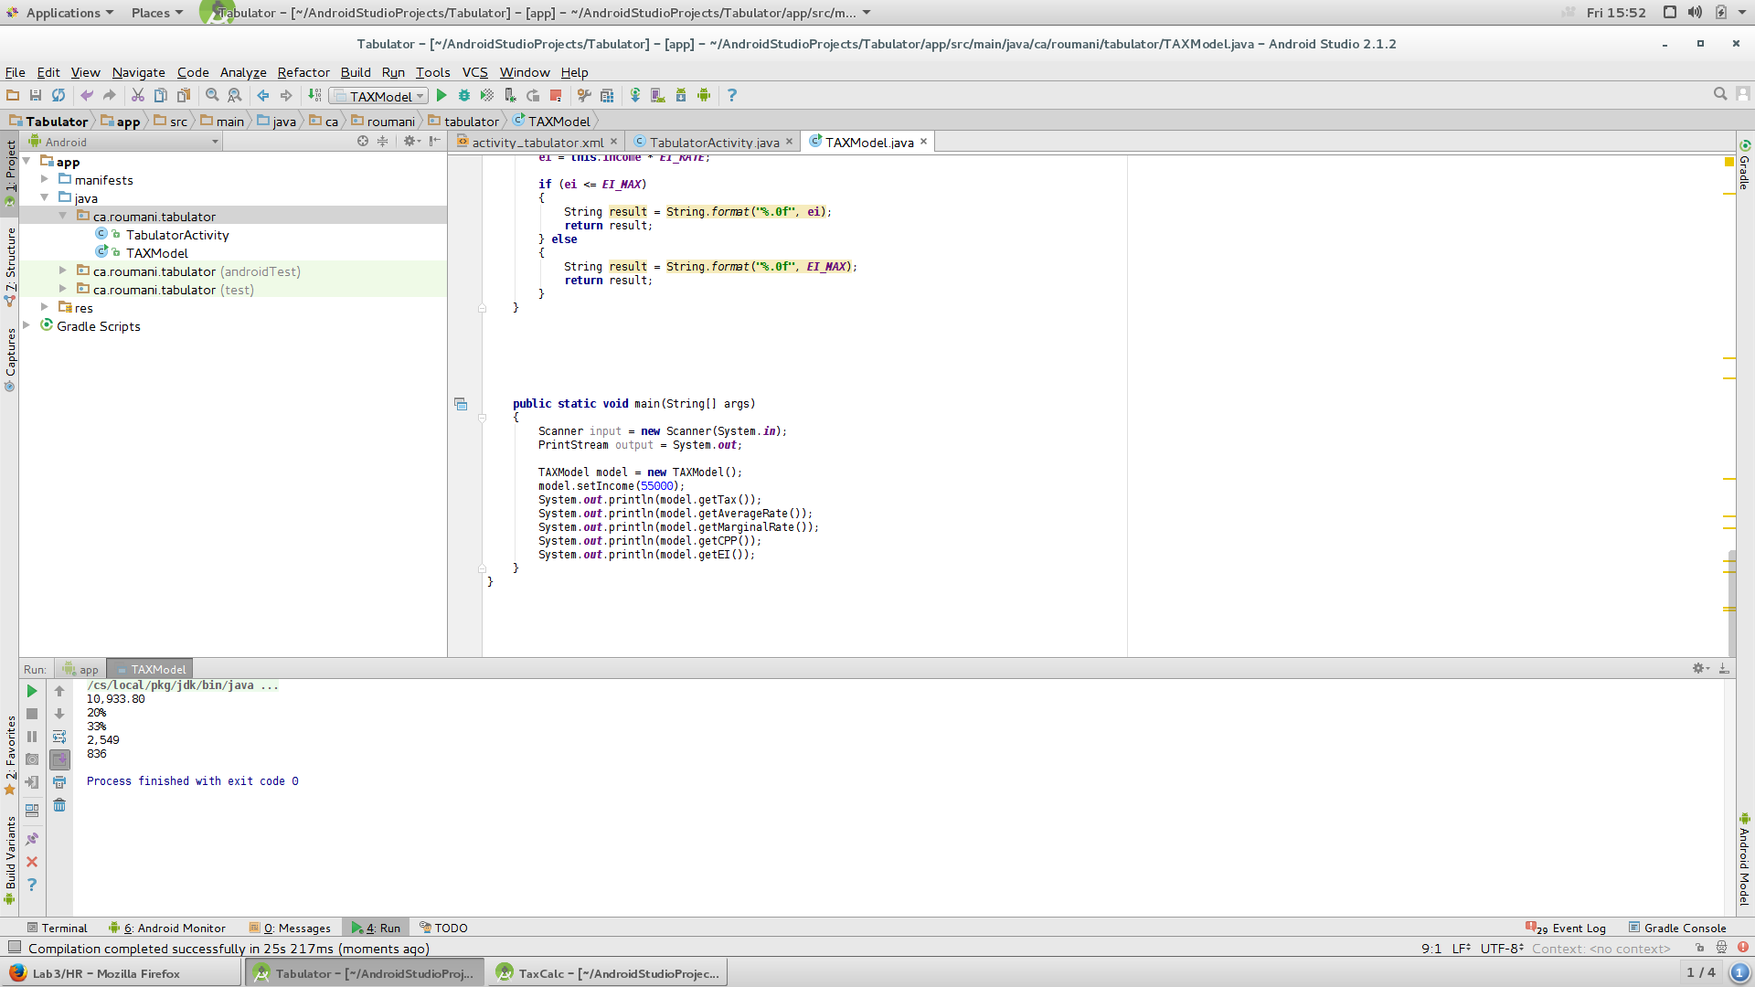

**Task 3:**Later we deployed it on the android tablet, by connecting it to the laptop.

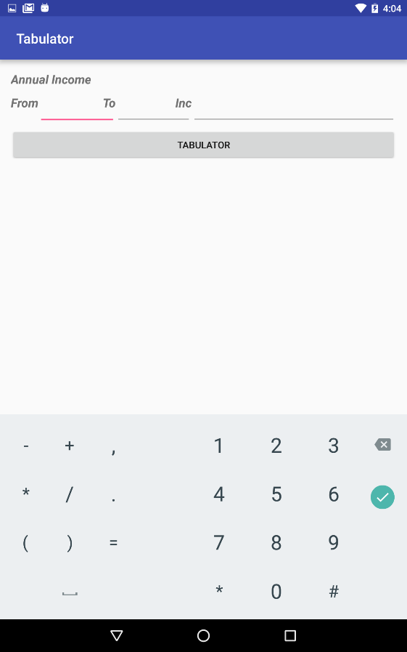

Screenshot after entering the Range of Annual Income and its Increment:

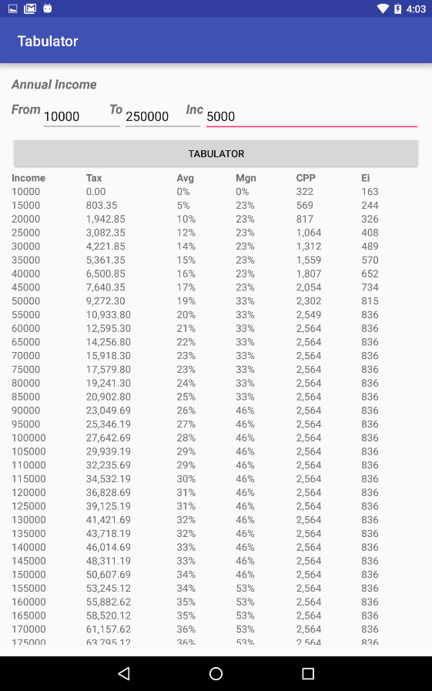

Herewith, I have attached the results and findings of this lab in the video format:

<https://youtu.be/gqqXga9Zstw>

**Discussion:**

Although the android studio was new to me, the walk through video posted by the professor helped me a lot in completing the lab. In particular the design option for creating the view of the app saved more time rather than typing the code itself. This lab was much easier, since the model for this program was similar to the one of lab 03. We only had to work on the Controller of the program. We found it difficult  to add the output in rows and columns ( Table View), otherwise the lab was much simpler comparatively.